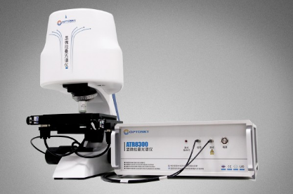
ATR8300MP miniature Raman microscope integrates microscope and Raman spectrometer. It features 2D Raman mapping and automated focusing. It becomes possible to see macro or micro areas of samples on the computer screen at just a single mouse click. When accurate positioning is visualized, the observer can detect Raman signals under various surface conditions, and synchronized Mapping can be displayed intuitively on the screen at one click operation. As a result, it provides great convenience to detect micro or macro areas of samples. Combine unique patented conjugate focusing(true confocal) system with accurate image processing algorithm, and it enables a very small sample area to be analyzed, as well as it requires minimal operator training and maintenance, yet resulting in uniform result not just spectra.

ATR8300MP is configured with tailor-made objective, and a laser spot on the sample becomes very close to the diffraction limit, then focal information can be displayed accurate and intuitive on the screen with a 3-megapixel camera. This configuration improves Raman spectral quality for overcoming the limitations of Raman systems where the focal plane for Raman signal collection is slightly above or below the images plane.

ATR8300 works stable with no moving components of optical path switch, hence it avoids loss of the optical path while images formed, and it gains an optimized signal from separating images formed from Raman signal collection.
RAMAN INSTRUMENT
Maximum Laser Output | 500mW (Max. 100mW for 532nm)
Wavenumber Range | 785nm(532, 633, 830, 1064nm for optional)
Thermal Stability | Spectral shift ≤ 1 cm-1 (10-40 ℃)
Detector | InGaAs cooled for 1064nm
SNR | >6000:1
Pixel Size | 14μm* 50μm
Microscope Camera | 3-megapixel /5-megapixel camera
Spectral Raliability | σ/μ < 0.5% (COT 8 hours)
Dynamic Range | 13000:1
Focusing | True confocal
Laser Output | >550mW ( software adjustable)
Laser Spot Diameter | >1μm
Laser Stability | σ/μ<±0.2%
Laser Linewidth | 0.08 nm
Connectivity | USB2.0
Electrical Controlled X.Y Axis 2D Platform | n/a
Moving Range | 5 X 5 cm
Scan Speed | 20mm/s
Focusing Accuracy | ≤ ±0.2μm
Z Axis, Auto-Focusing | n/a
Focusing Speed | Less than 10 s
Maximum Range | 20mm
OPTICAL PARAMETER
Wavelength Range | 200nm- 1100nm(available in customer wavelengths range down to 50cm-1)
ELECTRICAL PARAMETER
Resolution | 4 cm-1

Feature：
Full-automated Raman experiment, auto-focusing, auto-scan
Ultra-high sensitivity, SNR>6000:1
True confocal, accurate Raman mapping
Ultra-high spatial resolution
Unique software controlled to switch optical path
Ultra-high stability
Brand optical element, excellent performance
Fast positioning, quick locate the focal position
High quality objective, micro spot
3-megapixel camera, crisp clear images
Excitation wavelength(Optional): 532、785、830、1064
High performance spectrometer configured
USB2.0 in direct connect with PC

