1、Description：
Incident lights with wavelengths range between 200-1700nm vertically shine on the surface of thin film, when transmittance of thin film happen, ATGX310 can utilize lights reflected via upper and lower boundaries of thin film to create an interference pattern superimposed, the spacing of the pattern’s sinusoidal waves, when combined with the refractive index of the material, can be used to calculate the thickness of the materials.
2、What is the structure of Thin Film Measurement System?
Thin Film Measurement System compose of Fiber Optic Spectrometer（ATP3010P）,R3 Measurement holder( R3）,Deuterium Halogen Light Sources（ATG1020）, Fiber collimator（FIBH-2-UV）, and UV fiber（FIB-600-UV

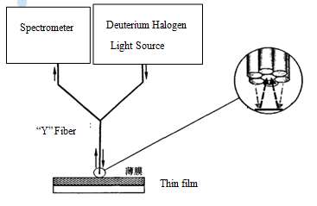
3、Features
Specifications:
1. Optical system:
Deuterium Halogen light source
Collimating mirror
Receiver：Optic fiber spectrometer
Wavelength：200-1100
Range measured：0-100%
Technical parameters:
Wavelength accuracy ±0.5nm
Wavelength repeat ≤0.2nm
Spectral bandwidth: 1nm
Stay light ≤0.05%
Transmittance accuracy ±0.5%
Transmittance repeat ≤0.5%
Datasheet of Thin Film Measurement System:
ATGX310 specification
Item | ATGX310-VIS | ATGX310-XR | ATGX310-DUV | ATGX310-NIR
Wavelength range | 400-850nm | 250-1060nm | 190-1100nm | 900-1700nm
Thick range | 50nm-20um | 10nm-100um | 1nm-100um | 100nm-250um
Thick resolution | 0.1nm | 0.1nm | 0.1nm | 0.1nm
repeatability | 0.3nm | 0.3nm | 0.3nm | 1.0nm
Incident angle | 90℃
Film Layers | Up to10 layers
Sample materials | Transparent/semi-transparent
Modes Measured | Reflectance & Transmittance
Rough film thickness measured | Yes
Speed measured | Minimum 1ms
Online | Y | Y | Y | Y
Light spot size | Standard: 200um or 400um
 | Customized: 100um
Microscope configured | Y
CCD imaging | Y
Scan options | 150mmX300mm | 150mmX300mm | 150mmX300mm | 150mmX300mm
 | Xy scan platform
Vacuum | Y

