PULSED FIBER LASER
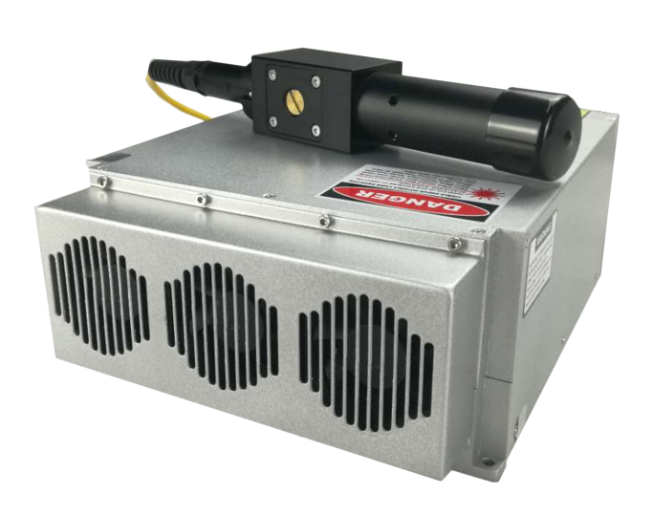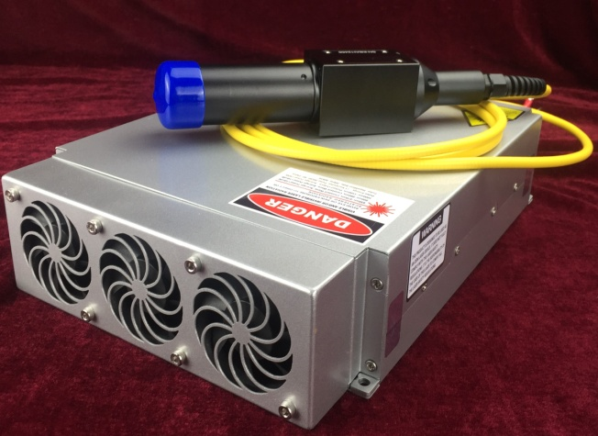
INTRODUCTION
GQM Series of pulsed fiber lasers are designed for high throughout industrial laser marking application. Compared to the traditional laser systems,the conversion efficiency from pump power to output power of fiber laser is 10 times higher. The low power consumption and compact design,benefited from the high efficiency and air cooling,makes the GQM Series the best choice for lab and industrial application,since it can be integrated into the customer equipment easily. GQM Series also have great immunity to EMI environment because of the full isolation between the control electronics and the customer interface,which brings convenience for system connection.

FEATURES
. Compact structure . Stable performance . Maintenance-free . High beam quality

APPLICATION
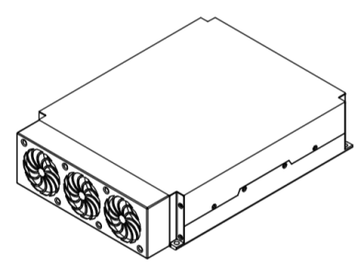
. Marking . Micromachining . Engraving . Scribing

PRODUCT SIZE(mm)
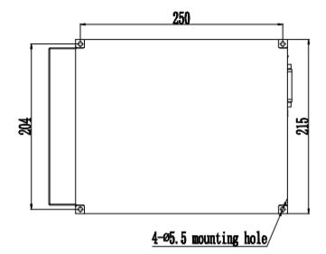
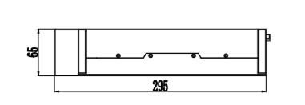
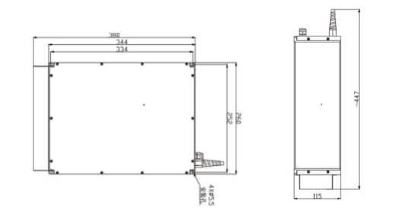
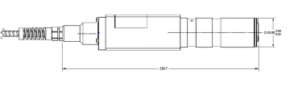
30W/50W/75W 10W/20W
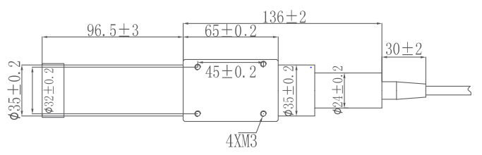
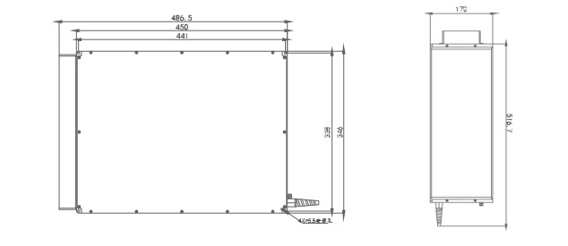
100W

SPECIFICATIONS
PARAMETERS | UNIT | GQM-010-0-W | GQM-020-0-W | GQM-030-0-W | GQM-050-0-H | GQM-075-0-H | GQM-100-0-H
Center wavelength | nm | 1064±3 | 1064±3 | 1064±3 | 1064±3 | 1064±3 | 1064±3
Beam quality | kHz | 20-80 | 30-80 | 25-80 | 50-100 | 75-150 | 100-200
Single pulse energy | % | ﹤5 | ﹤5 | ﹤5 | ﹤5 | ﹤5 | ﹤5
Polarization | mm | 7 | 7 | 7 | 7 | 7 | 7
Pulse width | / | ﹤1.5 | ﹤1.5 | ﹤1.8 | ﹤1.8 | ﹤2.0 | ﹤2.0
Band width | / | Random | Random | Random | Random | Random | Random
Repetition rate | ns | 90-110@20kHz | 110-130@30kHz | 90-110@25kHz | 90-110@50kHz | 120-140@75kHz | 150-200@100kHz
Average power | mJ | 0.6@20kHz | 0.65@30kHz | 1.10@25kHz | 1.05@50kHz | 1.05@75kHz | 1.05@100kHz
Output power tunability | m | 1.8±0.1 | 1.8±0.1 | 1.8±0.1 | 1.8±0.1 | 1.8±0.1 | 1.8±0.1
Output fiber cable length▲ | % | 10-100 | 10-100 | 10-100 | 10-100 | 10-100 | 10-100
Working voltage | V/DC | 24 | 24 | 24 | 24 | 24 | 24
Powerconsumption | W | 80±10 | 110±10 | 150±15 | 200±15 | 300±15 | 400±15
Cooling | / | Air Cooling | Air Cooling | Air Cooling | Air Cooling | Air Cooling | Air Cooling
Operating temperature | ℃ | 0-40 | 0-40 | 0-40 | 0-40 | 0-40 | 0-40
Dimension（W×H×D） | mm | 215×65×295 | 215×65×295 | 260×115×380 | 260×115×380 | 260×115×380 | 346*170*486.5
Weight | kg | 7.3 | 7.3 | 10 | 10 | 10 | 25
▲ CUSTOMIZED AVAILABLE

LOW POWER CW FIBER LASER
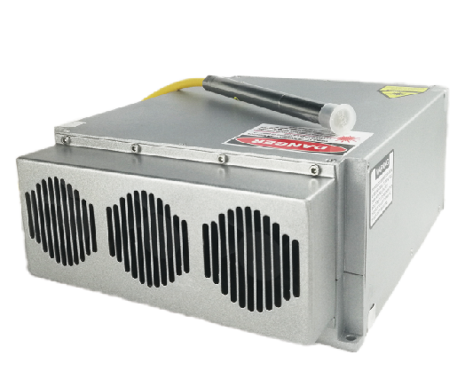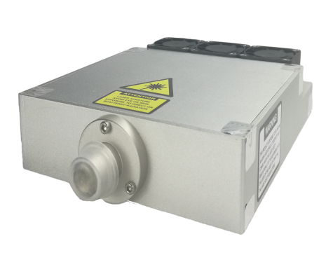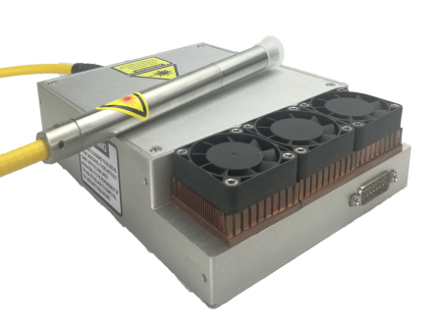
INTRODUCTION
GTL Series of continuous wave fiber lasers are designed for industrial materials processing application. This series of fiber laser are aimed to provide 5W to 30W CW laser power. It has the characteristics of high efficiency and high beam quality,simple structure.And the measured M² is usually below 1.1. This series of products are applied in the marking of IC chip and high quality optical source for scientific research,etc.

FEATURES
. High efficiency . High beam quality . Maintenance-free . Fiber delivery output

APPLICATION
. Marking .Optical Component Test . Scientific research

PRODUCT SIZE(mm)
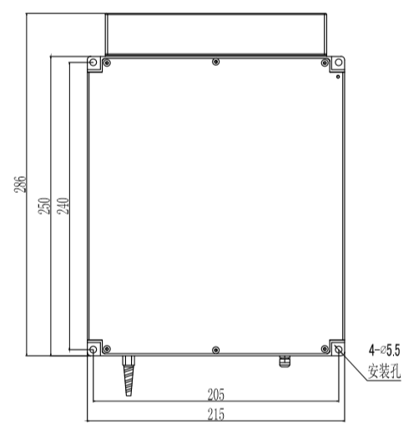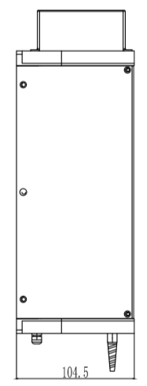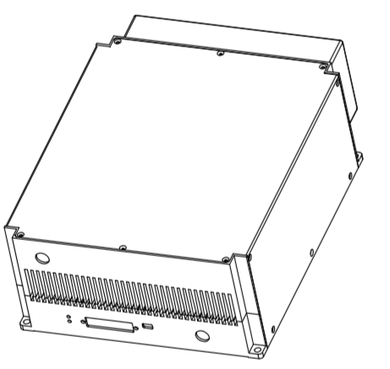
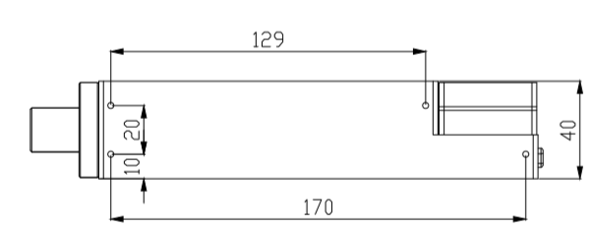
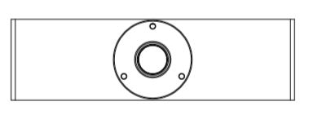
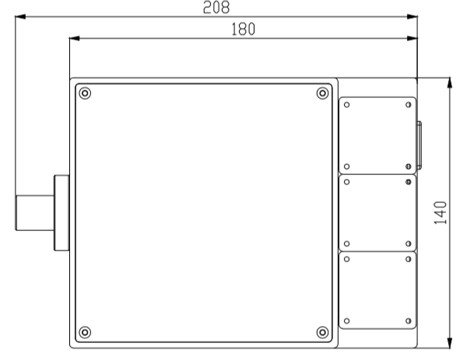

SPECIFICATIONS
PARAMETERS | UNIT | GTL-005 | GTL-010 | GTL-020 | GTL-030
CENTRAL EMISSION WAVELENGTH | nm | 1080 | 1080 | 1080 | 1080
BEAM QUALITY | M² | ＜1.1 | ＜1.1 | ＜1.1 | ＜1.1
OUTPUT POWER STABILITY | ％ | ±3 | ±3 | ±3 | ±3
POLARIZATION | — | RANDOM | RANDOM | RANDOM | RANDOM
EMISSION BANDWIDTH | nm | ＜3 | ＜3 | ＜3 | ＜3
MAX. MODULATION FREQUENCY | kHz | 10 | 10 | 10 | 10
NOMINAL AVERAGE OUTPUT POWER | W | 5 | 10 | 20 | 30
OUTPUT POWER TUNABILITY | ％ | 10-100 | 10-100 | 10-100 | 10-100
OUTPUT FIBER DELIVERY LENGTH | m | 2 | 2 | 2 | 2
OPERATING VOLTAGE | VDC | 24 | 24 | 24 | 24
OPTICAL HEAD▲ |  | QCS | QCS | QCS | QCS
INPUT/OUTPUT INTERFACE |  | DB25 | DB25 | DB25 | DB25
MAX.POWER CONSUMPTION ▲ | W | 30 | 70 | 90 | 110
COOLING METHOD | — | AIR COOLING | AIR COOLING | AIR COOLING | AIR COOLING
AMBIENT TEMPERATURE | ℃ | 0-40 | 0-40 | 0-40 | 0-40
DIMENSIONS (W*H*D) | mm | 140*40*180 | 140*40*180 | 215*104.5*286 | 215*104.5*286
NET WEIGHT | kg | 2.5 | 2.5 | 5 | 5
▲ CUSTOMIZED AVAILABLE

DEDIUM POWER CW FIBER LASER

INTRODUCTION
GTL Series of continuous wave fiber lasers are designed for industrial materials processing application,especially designed for high reflection material processing application such as copper,aluminum and so on.This series of fiber lasers are aimed to provide 200W-1.2kW CW laser power. It has the characteristics of high efficiency and high beam quality and the measured M² is usually below 1.1. The feature of high beam quality makes it be an ideal choice of materials processing application.

FEATURES
. High efficiency . High beam quality . Maintenance-free . Fiber delivery output

APPLICATION
. Fine cutting . Metal welding

PRODUCT SIZE(mm)
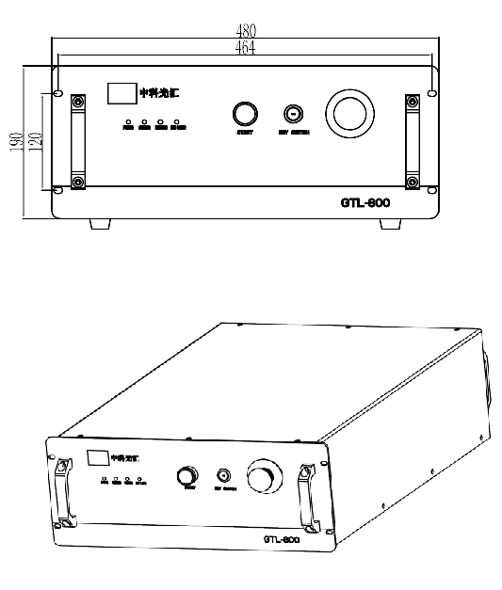

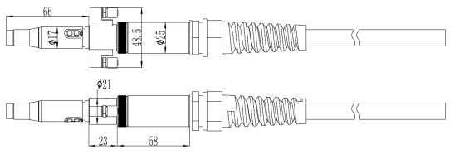

SPECIFICATIONS
PARAMETERS | UNIT | GTL-500 | GTL-800 | GTL-1000 | GTL-1500
CENTRAL EMISSION WAVELENGTH | nm | 1080 | 1080 | 1080 | 1080
BEAM QUALITY | M² | ＜1.3 | ＜1.3 | ＜1.3 | ＜1.3
OUTPUT POWER STABILITY | ％ | ±3 | ±3 | ±3 | ±3
POLARIZATION | — | RANDOM | RANDOM | RANDOM | RANDOM
EMISSION BANDWIDTH | nm | ＜6 | ＜6 | ＜6 | ＜6
MAX. MODULATION FREQUENCY | kHz | 10 | 10 | 10 | 10
NOMINAL AVERAGE OUTPUT POWER | W | 500 | 800 | 1000 | 1200
OUTPUT POWER TUNABILITY | ％ | 10-100 | 10-100 | 10-100 | 10-100
OUTPUT FIBER DELIVERY LENGTH | m | 15 | 15 | 15 | 15
OPERATING VOLTAGE | V/AC | 220 | 220 | 220 | 220
OPTICAL HEAD▲ |  | QBH | QBH | QBH | QBH
INPUT/OUTPUT INTERFACE |  | DB25/RS232 | DB25/RS233 | DB25/RS234 | DB25/RS235
MAX.POWER CONSUMPTION ▲ | W | 3000 | 3500 | 4600 | 5500
COOLING METHOD | — | WATER COOLING | WATER COOLING | WATER COOLING | WATER COOLING
AMBIENT TEMPERATURE | ℃ | 10-40 | 10-40 | 10-40 | 10-40
DIMENSIONS (W*H*D) | mm | 480*190*373 | 480*190*373 | 480*190*373 | 480*190*373
NET WEIGHT | kg | 55 | 60 | 63 | 65
▲ CUSTOMIZED AVAILABLE

